

# 

Assignment Cover Letter

(Individual Assignment)

|  |  |
| --- | --- |
| **Student Name:**  Christopher Samuel Tendi | 2440065030 |
| **Course Code:** COMP 6699 | **Course Name:**  Computer Science |
| **Class:** L2BC | **Name of Lecturer:**  Jude Martinez L |
| **Major:** Computer Science |  |
| **Title of Assignment:**  Household Spending |  |
| **Type of Assignment:** Final Project |  |
| **Due Date:**         22 - 06 - 2021 | **Submission Date:** 22 - 06 - 2021 |

The assignment should meet the below requirements.

1. Assignment (hard copy) is required to be submitted on clean paper, and (soft copy) as per lecturer’s instructions.
2. Soft copy assignment also requires the signed (hardcopy) submission of this form, which automatically validates the softcopy submission.
3. The above information is complete and legible.
4. Compiled pages are firmly stapled.
5. Assignment has been copied (soft copy and hard copy) for each student ahead of the submission.

# Plagiarism/Cheating

BINUS International seriously regards all forms of plagiarism, cheating and collusion as academic offenses which may result in severe penalties, including loss/drop of marks, course/class discontinuity and other possible penalties executed by the university. Please refer to the related course syllabus for further information.

# Declaration of Originality

By signing this assignment, I understand, accept and consent to BINUS International terms and policy on plagiarism. Herewith I declare that the work contained in this assignment is my own work and has not been submitted for the use of assessment in another course or class, except where this has been notified and accepted in advance.

Signature of Student:

Christopher Samuel Tendi

Christopher Samuel Tendi

# **Table of Contents**

1. **Introduction**
   1. Background
   2. Program Function
2. **Solution Implementation**
   1. Parts of the Program
   2. Data Dictionary
3. **Explanation of Code**
   1. HouseholdSpending.java
   2. SpendingDatabase.java
4. **Evidence of Working Program**

# Introduction

**Background**

When the final project was first introduced to us students, to be perfectly honest, I was confused on what to make for it. Thus, I immediately decided to research and look for ideas that might spark my interest and the most common results were databases, which is why I decided to go for that. Afterwards, I tried looking for a problem that could be solved by making a program, then I remembered a relative of mine that struggles to monitor and track their expenses. She mentioned that every month her family seems to have spent way more that what she thought. That gave me an idea. What if I could make a program that could calculate as well as store a household’s/individual’s monthly expenses.

During my research, I also found out that there are 2 ways of making an SQL database, either by hardcoding it using SQLite or by generating a local server through myPHP. I settled for the former due to personal preference after seeing the tutorials for both. I used IntelliJ as my IDE to program this project.

All the code, documentation and video evidences of this project can be found under this GitHub repository: <https://github.com/christophertendi/HouseholdSpending>

**Program Function**

The main purpose of this program is to find the total spending and average spending of a household/individual. This program also allows users to look back on expenditure of previous months and alter the values stored for each month as this program implements a database.

When the user first opens the program, a database will be automatically generated. The user would have to fill in the necessary inputs, which are, a dropdown of the months of a year and the amount of money they spent from the 1st to the 4th week of the selected month. All the inputted data will be saved inside a database, which can be overwritten anytime. Users can also check the data stored in other months for their weekly expenses if they happen to either forget how much they spent, or want to change the inputted data.

The program specifications are as follows:

* **Software and Libraries used:**
  + IDE: IntelliJ by JetBrains
  + SQLite for database
* **Input:**
  + Month
  + Expenses from week 1 to 4
* **Output:**
  + Total Spending
  + Average Spending of the 4 weeks
  + Expenses from week 1 to 4 (when user wants to look at expenditure of other months by pressing the “load” button)

# Solution Implementation

**Parts of the Program**

The program will contain a GUI form, designed by using the IDE. The user has to fill in 5 mandatory inputs which are (in order):

* Month - when the user clicks on the arrow, a dropdown will be shown asking the user to select the intended month
* Week 1 - user has to fill in the expenditure of week 1 of the selected month
* Week 2 - user has to fill in the expenditure of week 2 of the selected month
* Week3 - user has to fill in the expenditure of week 3of the selected month
* Week 4 - user has to fill in the expenditure of week 4 of the selected month

After the user has filled in the necessary inputs and clicked on “Calculate”, the program will calculate the **total spending** during that month along with the **average spending** of that particular month. Additionally, the user is also able to save the inputs of a particular month by clicking on the **Save** button and load it again through the **Load** button.

**Data Dictionary**

Spending.db

|  |  |  |
| --- | --- | --- |
| Field Name | Data Type | Description |
| month | VARCHAR | Selected month |
| Week1 | DOUBLE | User expenditure on week 1 |
| Week2 | DOUBLE | User expenditure on week 2 |
| Week3 | DOUBLE | User expenditure on week 3 |
| Week4 | DOUBLE | User expenditure on week 4 |

# Explanation of Code

HouseholdSpending.java

Figure 1. Declaration of Imports and Classes

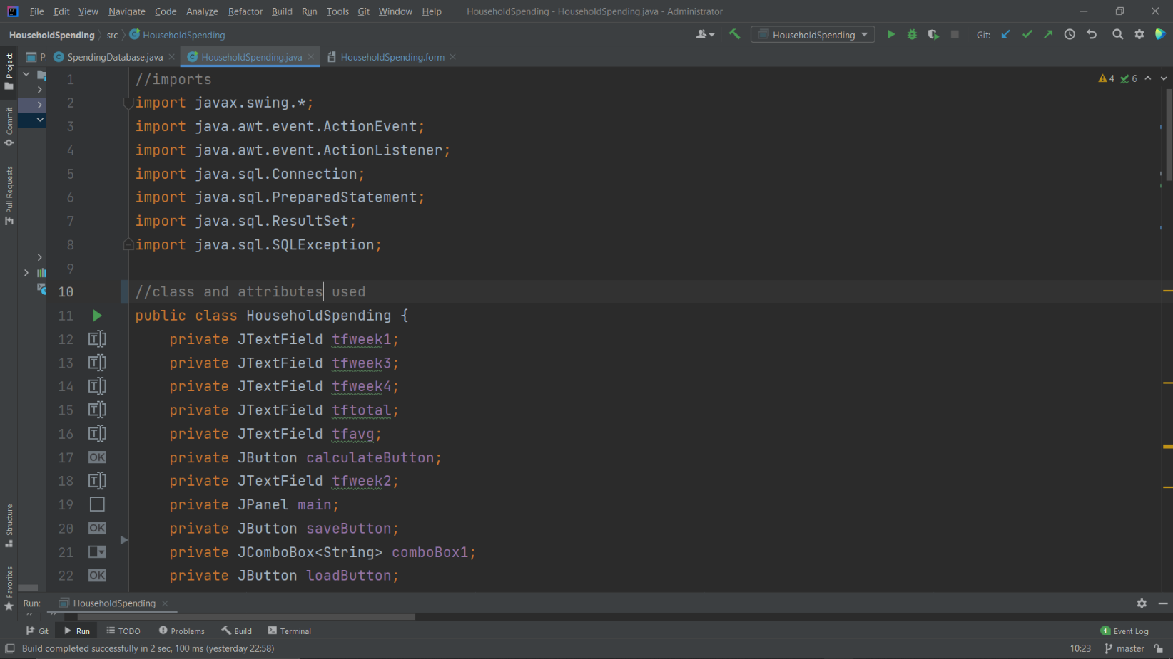

The figure above shows the imports used in this program, which is pretty self-explanatory. The public class HouseholdSpending is the main class in this program, it contains attributes that are used in the GUI form.

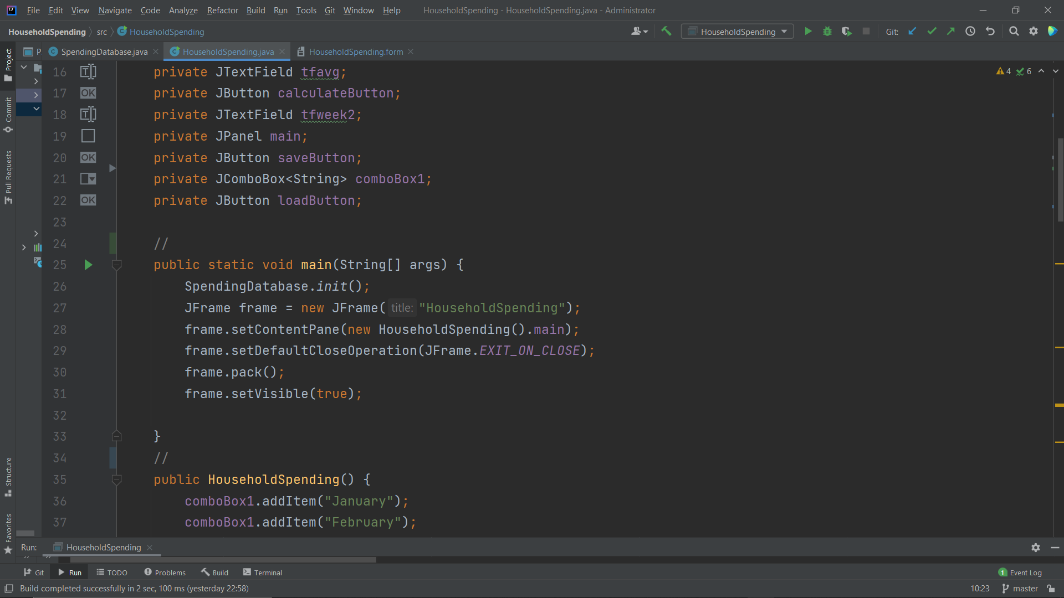

Figure 2. main function to run program

The figure above shows the main method of the program. **SpendingDatabase.init()** is the function used to initialize or call the functions in the **SpendingDatabase.java** class. **JFrame frame** is a variable that calls a window or frame for the program’s GUI.

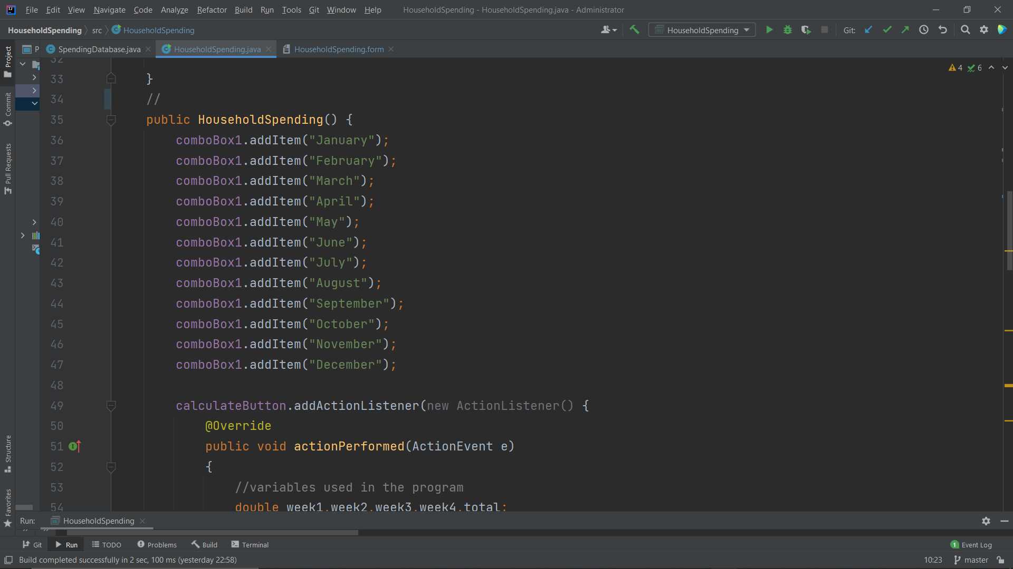

The figure above shows the start of the **HouseholdSpending** method. **comboBox1** is essentially the dropdown box that contains the months of a year from which the user could choose from. **comboBox1.addItem** adds the entered string, for example January, into the 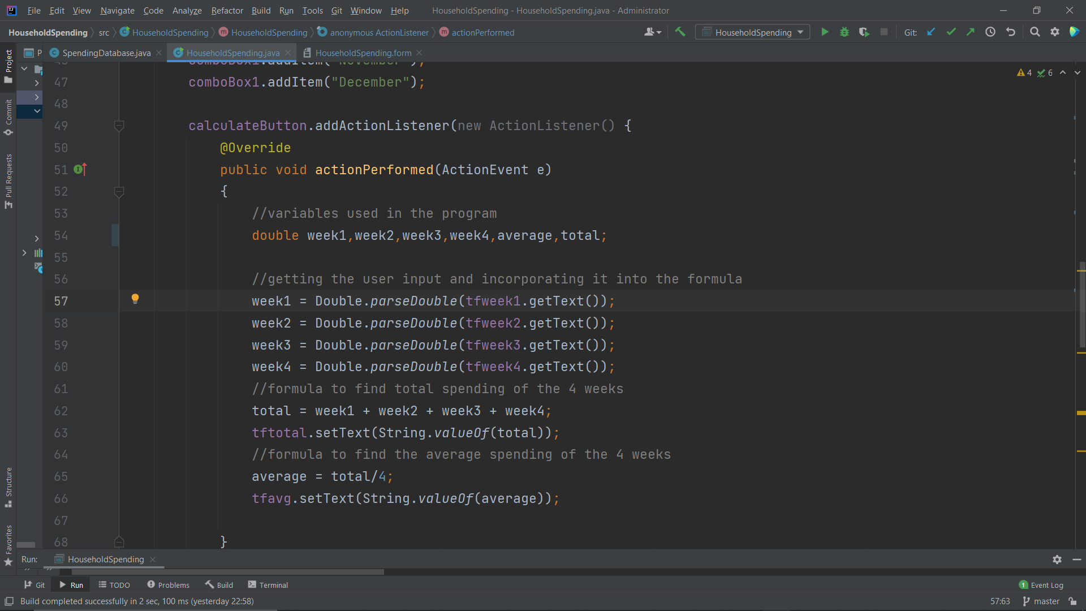dropdown.

The figure above shows the **calculateButton** attribute used in the program. **@Override** means that a child class is over-writing its parent class, this process is called inheritance. The **.addActionListener** adds a notifier that notifies the program that a button is clicked. Double is the data type used for all the inputs of the program. **Double.parseDouble** initializes a new variable for the inputted value. **getText()** extracts this inputted value, which is then used in the total and average variables to calculate the total and average amount spent. **valueOf()** is used to convert any given data type into a string.

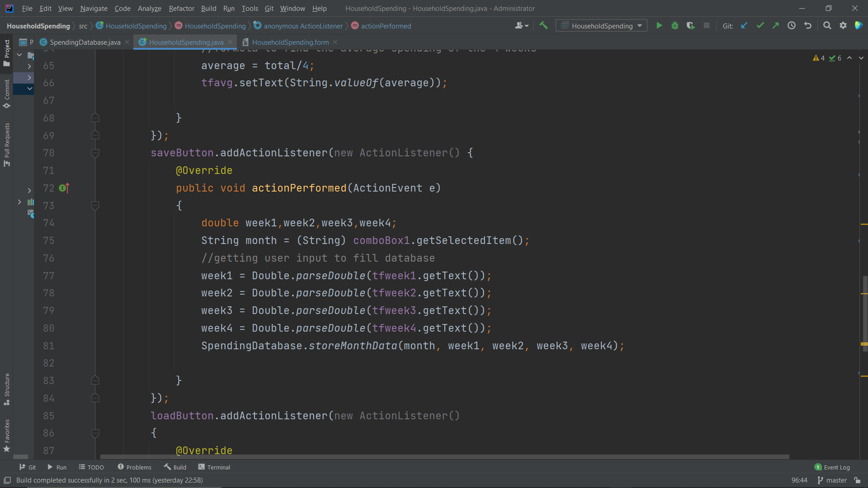

The figure above shows the **saveButton** attribute used in the program. Similar to calculateButton, **saveButton** is essentially used to save the inputted data into the database **spending.db**. **SpendingDatabase.storeMonthData** inserts the data into a table inside the **storeMonthData** method in the **SpendingDatabase** class, which we will get into when explaining this class later on.

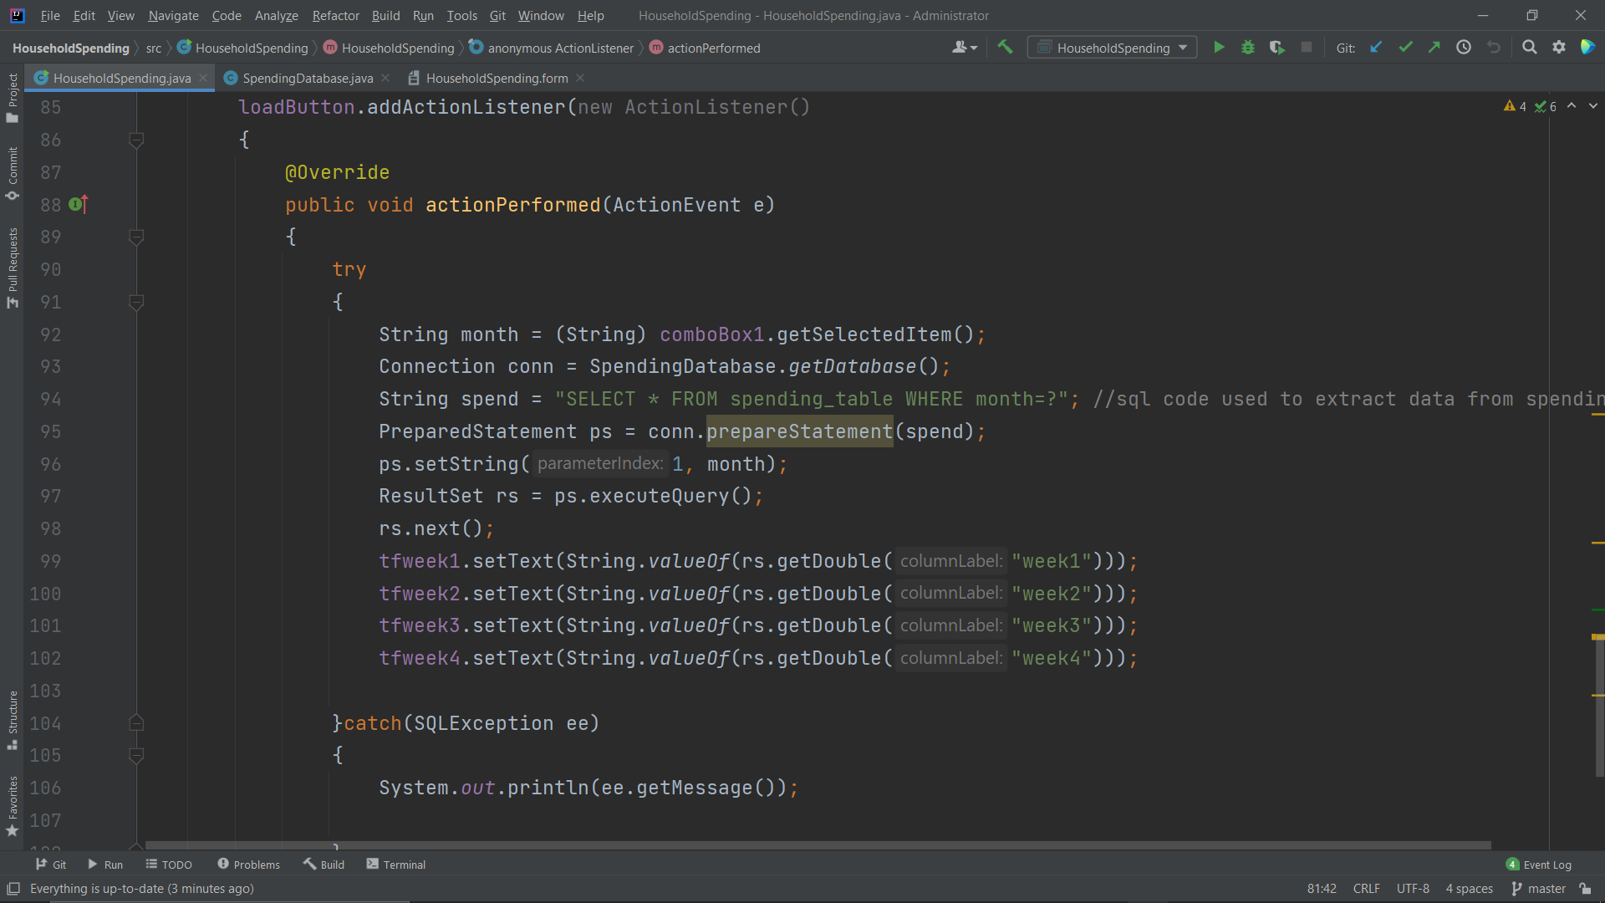

The figure above shows the **loadButton** attribute in the program. The try catch exception in java allows programmers to run their code despite having an error. Everything under “try” will be run whilst its errors are being tested. “catch” basically means that if an error occurs, the code under “catch” is the one that’s going to be run, in this case if there is an error, the system will print out an information regarding the SQL error. The String month variable is used to get the items in the month combo box. Connection conn is a variable used to get the values inside a Statement. The spend variable contains SQL code which translates to select everything from the **spending_table** (which contains the values stored for week 1-4) from a specific month. “?” means that the selected month depends on the user’s choice. Prepared statement is used to execute a query whereas ResultSet is used to call upon the specified row in the spending_table that contains the selected month. **.next()** is used to point towards the next row in the table.

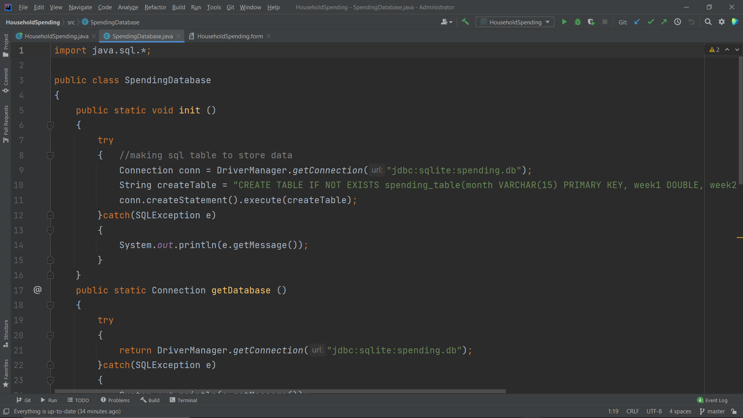SpendingDatabase.java

The figure above shows the code for SpendingDatabase class. The **init()** method contains a try and catch exception, which is explained in the previous class. The **DriverManager.getConnection** function sets the jdbc driver used to store the spending.db database. The **createTable** variable contains SQL code to create a table named **spending_table** inside the database, which is absolutely necessary in order to be able to store values inside the database.

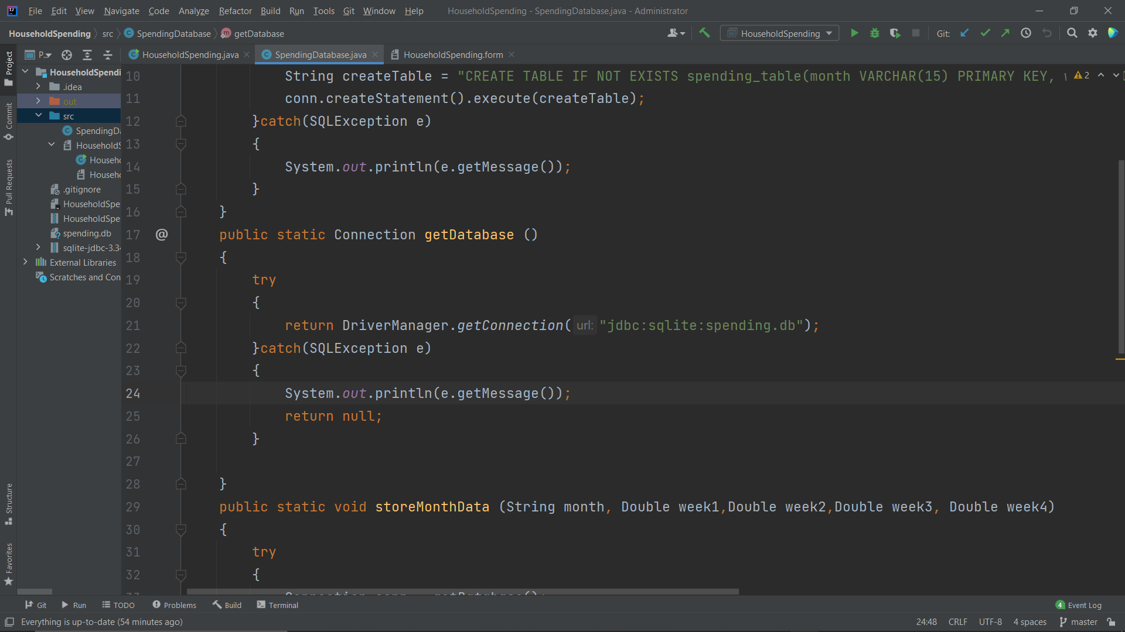

The figure above shows the **getDatabase** method, which is used to establish a connection between the SQL driver and the database

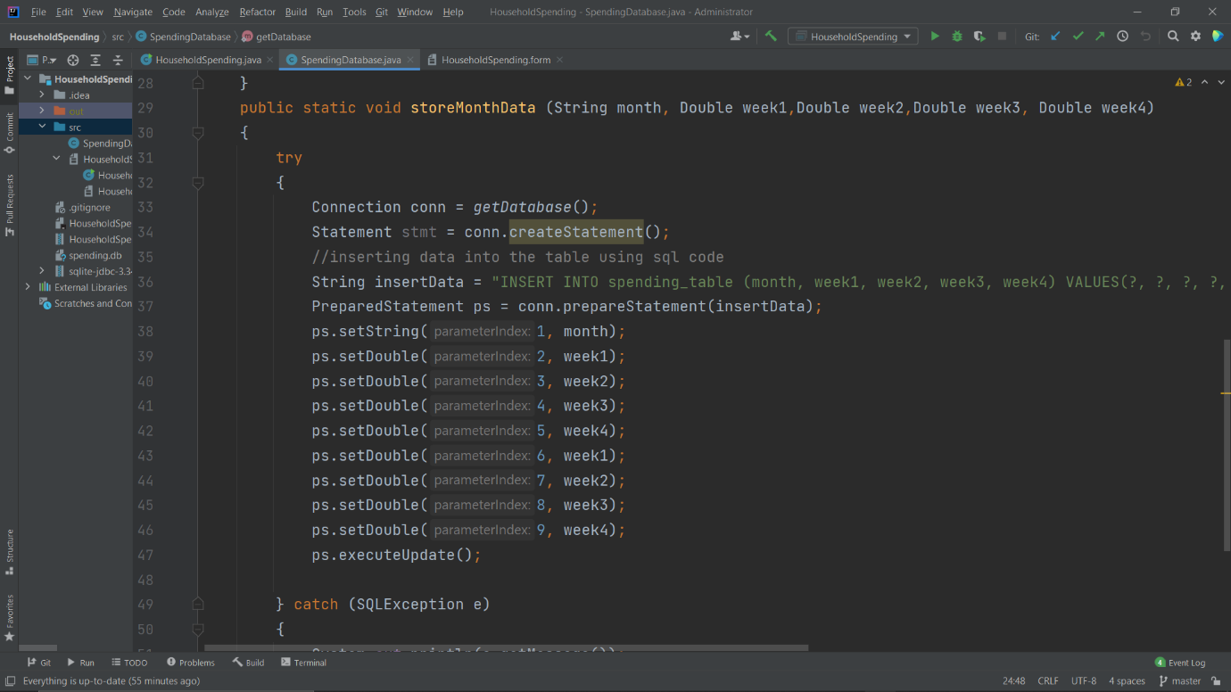

The figure above shows the **storeMonthData** method, which is used to store the inputted values month and the 4 weeks as mentioned in the explanation for the previous class. **PrepareStatement** **ps** is a variable that contains the data values before it is stored inside the database. There are 8 parameter indexes in the **setDouble** function for the weeks as 4 are used to store the initial values and the other 4 is used to store the newly inputted values if the user wishes to change the weekly expenditure of a particular month. **executeUpdate** is used to apply that change into the **spending_table**.

# Evidence of Working Program

# 